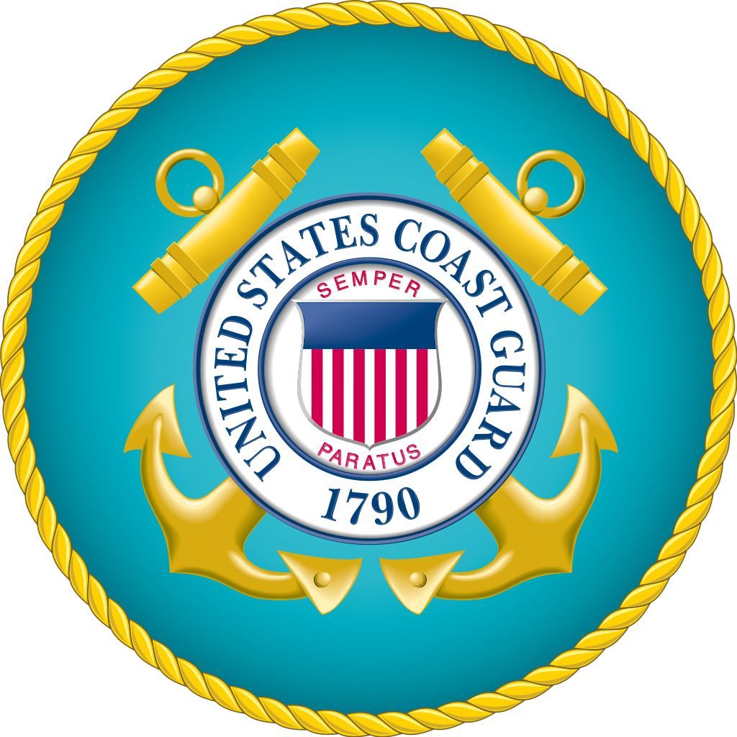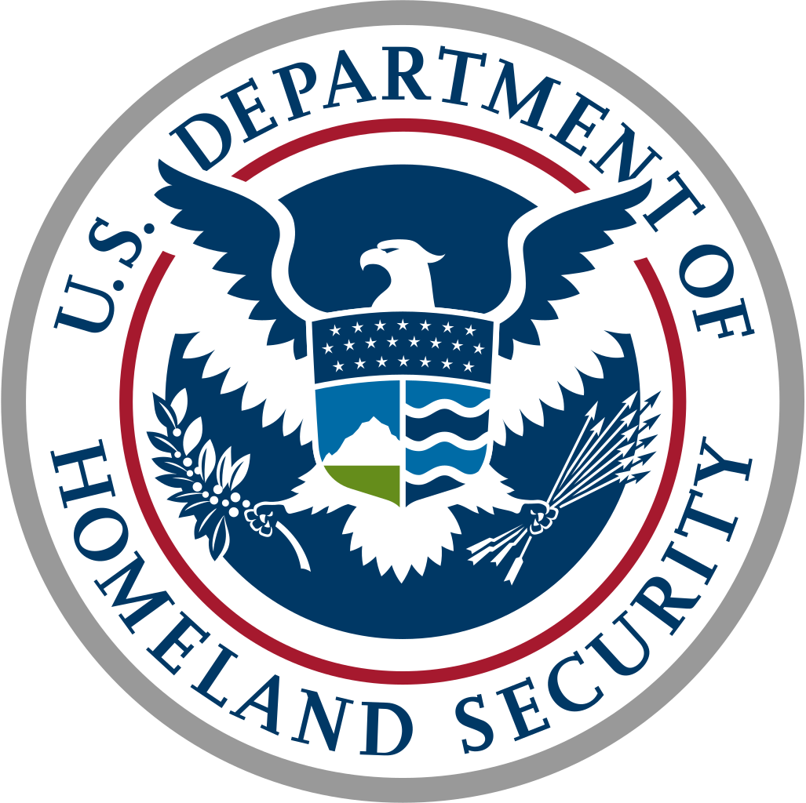 Master Chief Petty Officer

Radford Hoffpauir

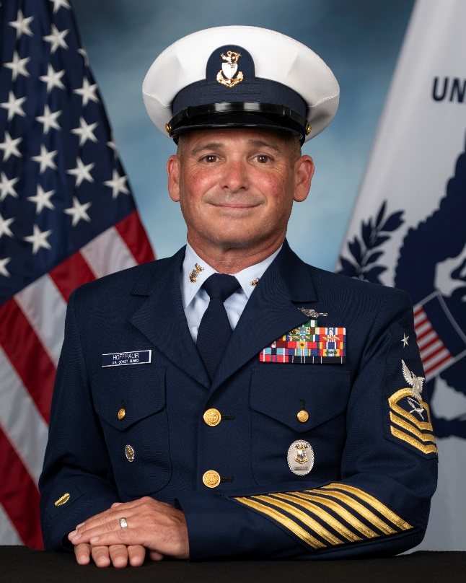Master Chief Petty Officer Radford Hoffpauir assumed the duties of Command Master Chief on June 17, 2022, and serves as the Command Senior Enlisted Advisor for all U. S. Coast Guard missions on Training Center Cape May. As the senior enlisted advisor to the command, Master Chief Hoffpauir advises on workforce issues and initiatives relative to the activities of the Training Center and the impact on the recruits, staff and families that call Cape May home.

He most recently served as the Culinary Specialist Rating Knowledge Manager at Coast Guard Training Center Petaluma, California.

Master Chief Hoffpauir’s previous assignments include: Station Cape Canaveral, Integrated Support Command (ISC) New Orleans, and as the Food Service Officer on Cutter Sitkinak, Cutter Cobia, Sector Key West, and Cutter Marlin.

Following these tours, as Food Service Officer and Command Chief/Senior Chief, he served on Cutter Mohawk, Cutter Dallas, and Cutter Hamilton.

During his distinguished career, Master Chief Hoffpauir earned the permanent Cutterman insignia and received three Coast Guard Commendation Medals with the Operational Distinguishing Device, five Coast Guard Achievement Medals with the Operational Distinguishing Device, and other personal and service awards.

Master Chief Hoffpauir is a graduate of the Chief Petty Officer Academy, the Air Force Senior Non Commissioned Officer Academy, the National Defense University’s Senior Enlisted Joint Professional Military Education (SEJPME), and of the Coast Guard’s Senior Enlisted Leadership Course. In addition, he is also certified in Applied Suicide Intervention Skills (ASIST) and Critical Incident Stress Management (CISM).

Master Chief Hoffpauir is from Crowley, Louisiana, and is married to the former Dawn E. Signorelli from Crowley, Louisiana. They have two beautiful daughters, Dacey Elizabeth Hoffpauir and Riley Jae Veliz and three amazing grandsons, Joseph Bryan Veliz III, Bradley Wayne Veliz and Hunter Earendil Fox.