EMT REFRESHER Course Homework
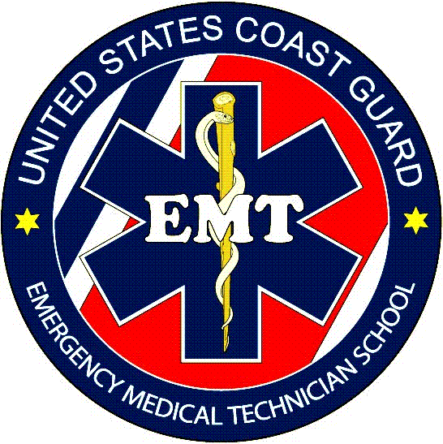
DAY 1 Homework Assignment
Read Emergency Care & Transport of the Sick & Injured 11th Edition:
Chapter 33, Chapter 34, & Chapter 37
11th Edition Workbook: Chapter 33 pg 385-386
Assessment Review Questions: 1-5
11th Edition Workbook: Chapter 34 pg 394-395
Critical Thinking Questions: 1-5
11th Edition Workbook: Chapter 37 pg 426-427
Critical Thinking Questions: 1-5

DAY 2 Homework Assignments
Read Emergency Care & Transport of the Sick & Injured 11th Edition:
Chapter 2, Chapter 19, Chapter 20, & Chapter 39
11th Edition Workbook: Chapter 2 pg 13
Critical Thinking Questions: 1-5
11th Edition Workbook: Chapter 19 pg 215-216
Assessment Review Questions: 1-5
11th Edition Workbook: Chapter 20 pg 225-226
Assessment Review Questions: 1-5
11th Edition Workbook: Chapter 39 pg 446-447
Assessment Review Questions: 1-4

DAY 3 Homework Assignments
Read Emergency Care & Transport of the Sick & Injured 11th Edition:
Chapter 22, Chapter 35, & Chapter 36
11th Edition Workbook: Chapter 22 pg 246
Assessment Review Questions: 1-5
11th Edition Workbook: Chapter 35 pg 409
Critical Thinking Questions: 1-5
11th Edition Workbook: Chapter 36 pg 420
Assessment Review Questions: 1-4

