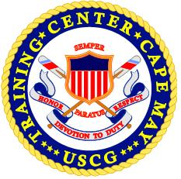

MARQUEE REQUEST FORM

ALL MARQUEE REQUESTS MUST BE APPROVED BY
YOUR DIVISION OFFICER PRIOR TO SUBMISSION TO
TRACEN CAPE MAY POLICE DEPARTMENT

DATE RANGE:
LETTER COLOR:
INBOUND/OUTBOUND:

- LIMITED TO 15 CHARACTERS PER LINE
- LIMITED TO 3 TOTAL LINES
- ALL REQUESTS MUST BE RECEIVED BY THE CGPD AT LEAST 48 HOURS PRIOR TO LISTING

___________________ ____________________
SUBMITTED BY APPROVED BY

