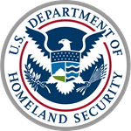
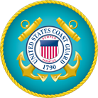
Commander Brad Conway
Executive Officer

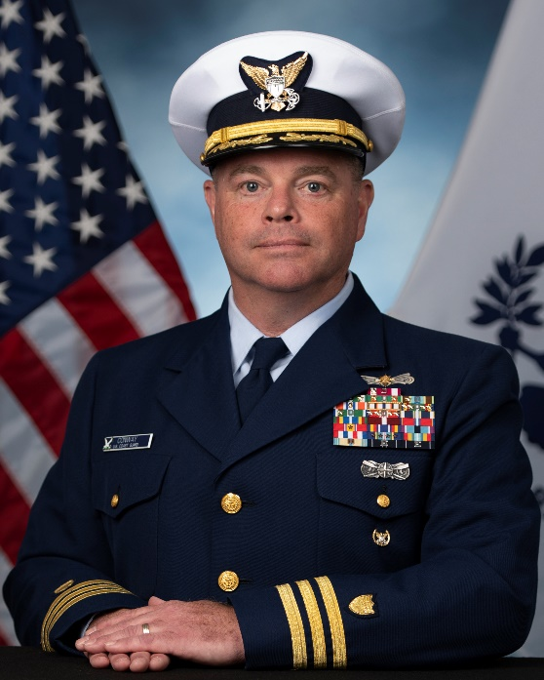
Commander Brad Conway reported to Training Center Cape May in July 2021 as the Executive Officer where he currently serves. A native of Birmingham, Alabama, Conway enlisted in the Coast Guard in 1989 and was assigned to Omega Station Kaneohe in Hawaii. In 1991, then Seaman Boatswain’s Mate Conway transferred to Station Honolulu where he served as an Officer of the Day (OOD), Coxswain, Boarding Officer, Unit Training and Weapons Petty Officer.
In 1993, Conway transferred to the Reserves as a petty officer to pursue his bachelor’s degree at the University of Hawaii. He continued to serve in the Reserves drilling at Station Honolulu. He transferred to Group Honolulu as a Group Search and Rescue (SAR) Controller in 2001. After 9/11, he was recalled to active duty to help stand-up the first Field Intelligence Support Team in Honolulu, serving as SAR controller, Ready for Operations Team member.
Conway graduated Officer Candidate School in July 2003 assigned to the Cutter Rush as an ensign. His duties included OOD, communications, electronic warfare, helicopter control, public affairs, boarding officer, and Mutual Assistance officer. In 2005, a newly promoted LTJG Conway transferred to Pacific Area Intelligence & the Maritime Intelligence Fusion Center Pacific in Alameda, California, where he served as an intelligence watch officer and the tactical intelligence analyst for illicit smuggling.
Conway transferred to Sector San Francisco in 2008 as the Deputy Chief of Contingency Planning and Forces Readiness where he managed all active duty and reserve readiness functions, contingency planning, Ready for Operations, and external affairs efforts as a lieutenant. Conway worked at Sector San Diego as Chief of the Joint Harbor Operations Center as a follow-on assignment. He led a team of 50 active duty, reserve, Auxiliary, California National Guard members, and port partners in the execution of SAR and counter smuggling and human trafficking operations there.
In 2014, LCDR Conway was assigned to Headquarters in the Office of Search and Rescue, as a policy analyst where he contributed to the development and execution of SAR policies and planning. In 2018, Conway assumed Command of Coast Guard Station New York in Staten Island, the largest station in the country, conducting SAR, law enforcement, and maritime security operations throughout the ports of New York, New Jersey and along the Hudson River. He was promoted to commander on Oct. 1, 2019.
Conway’s awards include two Meritorious Service Medals, three Coast Guard Commendation Medals, three Coast Guard Achievement medals, and two Commandant’s Letter of Commendation ribbons. In addition, he earned the permanent Coxswain and Advanced Boat Forces insignias and holds a master’s degree from the Naval War College. Commander
Conway is married to the former Ms. Michelle Ching of Honolulu, Hawaii, and they have two daughters.

