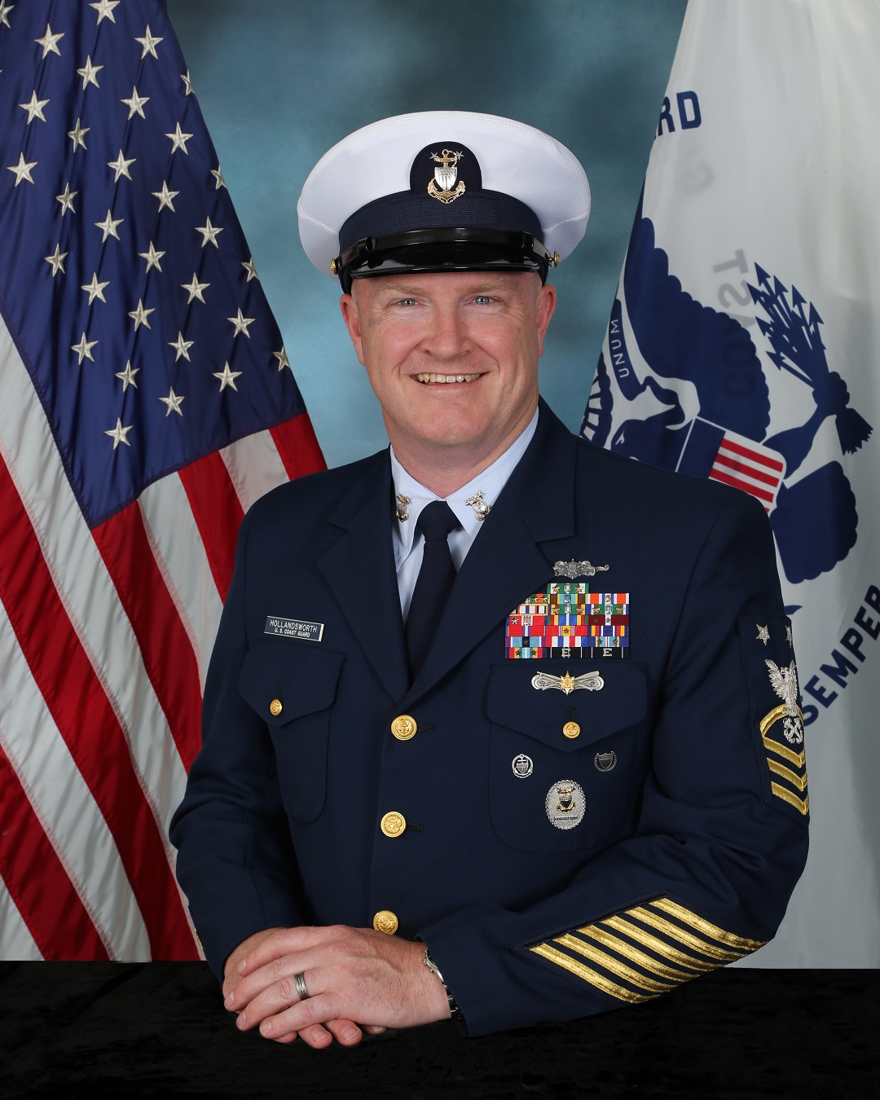
MCPO William Hollandsworth
United States Coast Guard
Command Master Chief
Training Center Cape May

Master Chief William D. Hollandsworth assumed his duties as the Command master Chief for Coast Guard Training Center Cape May in June of 2016. As the senior enlisted advisor to the Commanding Officer, Master Chief Hollandsworth advises him on workforce issues and initiatives relative to the activities of the Training Center and their impact on the recruits, staff and families that call Cape May home.

Prior to assuming his current position, Master Chief Hollandsworth was the Command Master Chief for US Coast Guard Patrol Forces Southwest Asia in Manama, Bahrain.
Master Chief first enlisted in the Coast Guard Reserves in 1988 and transferred onto active duty in 1991. His previous assignments include: Officer in Charge, USCGC MAKO, Cape May, NJ; Executive Petty Officer, USCGC MARIA BRAY, Jacksonville, FL; Officer In Charge, Station Rochester, NY; Executive Petty Officer, Station Chatham, MA; Operations Petty Officer, USCGC MONHEGAN, Key West, FL; Operations Petty Officer, Station Cape May, NJ; Instructor, UTB Systems Center, Coast Guard Training Center Yorktown, VA; USCGC MORRO BAY, Yorktown, VA; Physical Fitness Instructor, Coast Guard Training Center Cape May, NJ; Station Menemsha, MA; USCGC POINT STUART, Point Loma, CA; Coast Guard Reserve Group Sand Diego, CA.

Master Chief Hollandsworth is a proud graduate of Class 130 of the Chief Petty Officers Academy where he received the Spirit of the Chief Award, the Coast Guard Senior Enlisted Leadership Course class XX, the National Defense University’s Senior Enlisted Joint Professional Military Education course, and numerous other service related schools.

Master Chief Hollandsworth’s awards include the Meritorious Service Medal, three Coast Guard Commendation Medals with operational distinguishing device, five Coast Guard Achievement medals with operational distinguishing device, the Commandant’s Letter of Commendation Ribbon with operational distinguishing device, and numerous other personal and service awards. He has earned the permanent Cutterman, Coxswain, and Advanced Boat Forces Insignias, the Command Afloat and Ashore devices, and the Command Master Chief Silver Badge.

